The Holmes Platform

Software Requirements & High Level Design Document

Document Type Software Requirements

Document Code  SRD-2008-01 | Revision  1 | Pages 8
Produced by
JOSE MANUEL GOMEZ ALVAREZ
Change History
Created in January 2008. Original version from April 2004.
Updated December 2009.

Distribution List

PUBLIC

Reviewed by  JOSE MANUEL GOMEZ ALVAREZ | Approved by  JOSE MANUEL GOMEZ ALVAREZ
Signature | Signature
Date  28-12-2009 | Date  28-12-2009

Introduction
The Holmes Platform is the software platform developed by Irisel Consulting to deliver IT solutions.
This document presents an overview of the platform, the goals and vision of the project, the platform features and architecture.

Vision
The top-level goal of the platform is to provide a common framework on which to build enterprise applications such as CRM, Ordering, Inventory, Billing, etc.
The platform consists of:
- Generic front-end application (GUI) to browse the application data and services.
- Back-office modules to automate background jobs.
- APIs to extend these applications or to build new applications.
- Development facilities, such as the Data Exchange utility that enables data migration between a development database and a production database.
- Predefined business applications such as Holmes CRM.

Requirements
The Holmes Platform requirements can be sorted out in the following categories:

Non-Functional Main Requirements
- Platform independent. The software is written in Java, which means that the software can run on most widely used platforms (see platforms supported)
- Database independent. Thanks to the JDBC API, the software is quite independent of the database type, with minor adjustments. Target database servers include Oracle, Microsoft SQL Server and MySQL.
- Application independent. The core layers are completely decoupled from the application datamodel and business logic. Therefore, the architecture is reused across different business applications.
- Scalability & Performance. The performance of the system has been measured and optimized. The multilayer approach for enterprise users is scalable and based on standards such as the Web Services standard from the W3C or the Sun’s J2EE technology.

Technical-Functional Areas
- Front-End / GUI. A generic front-end to access the application data and services.
- Back-End. Application server and components to implement background processes.
- Web & Mobile. Architecture web-enabled and mobility platform for PDAs and mobile phones.
- API. The Platform includes APIs to extend the baseline applications or build new ones.
- Development. The platform includes tools to configure most aspects of the baseline applications, for data migration and for the database schema management. The application does not provide a Java IDE or Database administration tools, these are popular products already available in the market, both commercial and freeware.

Front-End Requirements
- Generic (Automatic). The front-end application has default auto-generated views to access the application data in a generic way. When the default view does not meet the user requirements, a custom view can be designed to override the default view.
- Easy. The generic forms are standard so its use is standard. The record fields are organized coherently so that the information is easy to find.
- Fast. Saving time is saving money, therefore the user time must be optimized.
- Powerful. Drop-down lists, calendars, pictures, links, multi-media support and attachments are some requirements met by the Holmes GUI.
- Customizable. To be able to adapt to different user requirements, many aspects of the interface are configurable without programming, such as menu items, lists, descriptions… By programming, almost every aspect may be changed. Forms can be extended or full overriden, the GUI Controller can be extended too, providing the hook to implement plug-ins.
- Automation / Integration. Integrate with other client components, automatic execution (macros), etc.

Back-End Requirements
- Application Server
- Batch Scheduler
- Monitoring System
- Management Server

Web & Mobile Access
- The client front-end application for Enterprises is based on Web services and can run over the web protocol (HTTP) so it can be used outside the Enterprise network via web through firewalls.
- To ease installation and upgrade of client applications, Java Web Start will be used.

API Requirements
- Architecture. The architecture is designed to enable the growing of the application while keeping the developer work as simpler as possible. The packages are designed following the standard layers (data, business logic & integration, client) while trying to reduce the coupling between them.
- Stability & Reuse. Software reuse has been taken very seriously. Duplicated software leads to duplicated errors and incoherent behaviors, and stability is a must for enterprise applications.
- Error management. Exception handling has been carefully designed to provide the application controller all necessary data to take the best decision in case of an exception.
- Functional requirements are to support the development of each of the functional areas described herein this document.

Development Tools
- Data Exchange. Tool to export/import data between databases. The referencial integrity of the data is kept, which means that the relationships between the records are preserved, in contrast with the database exchange tools.
- Schema Manager. The schema manager is used to compare the data model schema between different databases, and to align both schemas.

Hardware Architecture
The Holmes Platform has a 3-layered architecture:
- Database Server
- Application Server
- Client
There are three different clients:
- The DB Client is used for users located in the company intranet, typically for small deployments. This client connects directly to the database (2-tier deployment). Recommended for SOHO customers.
- The Web Client uses HTTP(S) to connect to the application servers. It is a fully-featured java client for remote users, for scalable, secured, 3-tier deployments. Recommended for enterprise customers.
- The Web application can be used from a web browser. It does not require installation so it is the recommended approach for occasional users, self-service sites for customers, etc.
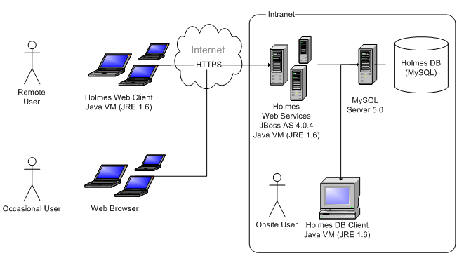

Software Architecture

Package Diagrams
The Holmes Platform software is grouped in Java packages, which are instead groups in projects or layers, containing the applications and API to develop application extensions as well as new applications.
This top-level diagram shows the main groups of packages and its relationships:
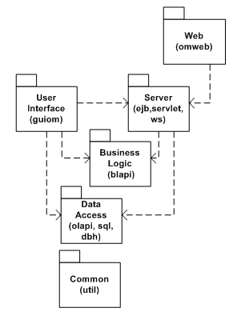
The following diagram shows the relationships between the packages (excluding the Server and Web groups):
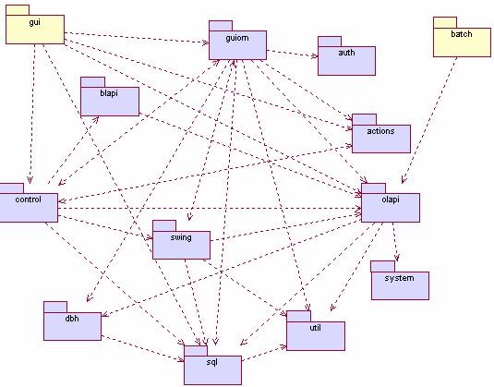
Image 1. Holmes Platform Package Diagram

Data Access Layer
- OLAPI. API to access data records and application data such as lists or descriptions.
- SQL. API to produce SQL statements using object-oriented programming.
- DBH. Database Handler. Manages the JDBC connectivity with the database. This package is internal.
Business Logic Layer
- BLAPI. API to access business services.
- EJB, WS, SERVLET. Packages containing J2EE & Web Services to provide data and business services (multilayer architecture).
Front-End Applications
- GUIOM. Database Client application. The GUIOM aplication is the generic customizable GUI client application that provides the functionalities to access the application data and services. This package is based on Swing, the standard APIs of the Java language to build graphical user interfaces. Internally, it has the following children packages:
  - ACTIONS. User actions package.
  - SWING. Extensions of Swing components.
  - CONTROL. Interface controller and delegates.
- GUIOM / WS.CLIENT. Web services version of the Client.
- DataExchange. Application to export/import data from Holmes databases.
- Batch Example. A batch (background program) example is included to show how to design and run batches using Holmes.
Common Libraries
- UTIL. Utility classes for miscellaneous use.
- SYSLOG. Legacy logging API. Deprecated in favor of Apache’s Log4Java.
- SYSTEM. Contains internal classes.
- MODULES. Plug-in architecture. For future use.

Deployment Diagram
The figure shows the distributable components and the node where they are deployed.
- XOMS.jar. Contains the Client classes and required common libraries.
- OMBrowser.ear. J2EE Enterprise Archive that contains the server side software.
- OMWeb.war. The web application. Depends on OMBrowser.ear.

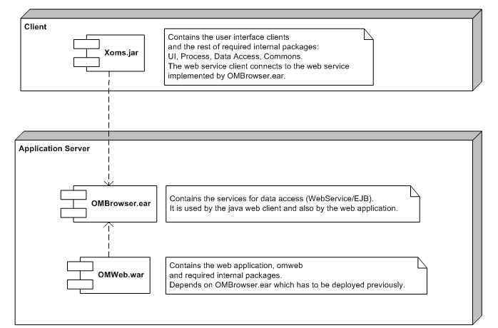

Platform Requirements
Language | Java. JDK 1.6.0
Database | JDBC - MySQL
Operating System | Independent from O.S.  (Windows / Unix)
Appication Server | JBoss 4.0.4 RC1

